**EXPERIMENT 6**

**Aim :**

Write a Program to Perform Sorting of Numbers in Descending Order in 8086 Microprocessor.

**Requirements :**

8086 Emulator Software.

**Procedure :**

1. Open 8086 Emulator, click on new and select BIN template.
2. Write the code in assembler window.
3. After writing the code in window, click on the emulate button.
4. Check for errors and fix them.
5. If the code is correct, emulator window will popup where we have to input values at defined locations.
6. Input the values using extended value viewer and click on the run button.
7. Observe the result of sorting in descending order at defined location.

**Program to Sort Numbers in Descending Order :**

|  |  |  |  |
| --- | --- | --- | --- |
| **Address** | **Mnemonics** | **Operands** | **Comments** |
| 0000H | MOV SI | 1600H | Move the value from 1600H to SI (Counter) |
| 0003H | MOV BX , [SI] |  | Give effective address of SI to BX |
| 0005H | DEC BX |  | Decrement BX by 1 |
| 0006H | AHEAD1 **|** MOV CX , [SI] |  | Give effective address of SI to CX |
| 0008H | DEC CX |  | Decrement CX by 1 |
| 0009H | MOV SI | 1602H | Move the value from 1602H to SI |
| 000CH | AHEAD **|** MOV AL , [SI] |  | Give effective address of SI to AL |
| 000EH | INC SI |  | Increment SI register by 1 |
| 000FH | CMP AL , [SI] |  | Compare the contents of Al and SI |
| 0011H | JNB AHEAD2 |  | Jump to AHEAD2 (0019H) if operand 1 > 2 |
| 0013H | XCHG AL , [SI] |  | Exchange the contents of AL and SI |
| 0015H | DEC SI |  | Decrement SI register by 1 |
| 0016H | MOV [SI] , AL |  | Move AL content to effective address of SI |
| 0018H | INC SI |  | Increment SI register by 1 |
| 0019H | AHEAD2 **|** LOOP AHEAD |  | LOOP if CX ≠ 0 |
| 001BH | DEC BX |  | Decrement BX by 1 |
| 001CH | MOV SI | 1600H | Move the value from 1600H to SI |
| 001FH | JNZ AHEAD1 |  | Jump to AHEAD1 (0006H) if ZF = 0 |
| 0021H | HLT |  | End of program |

**Screenshots :**

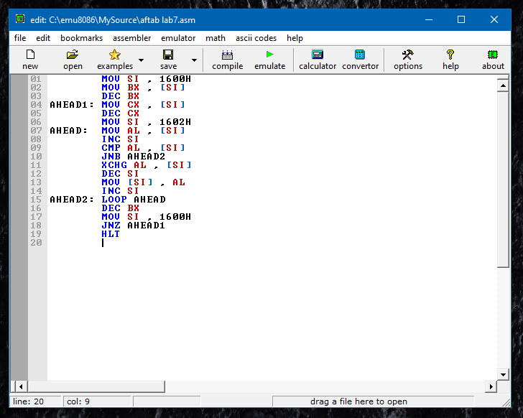

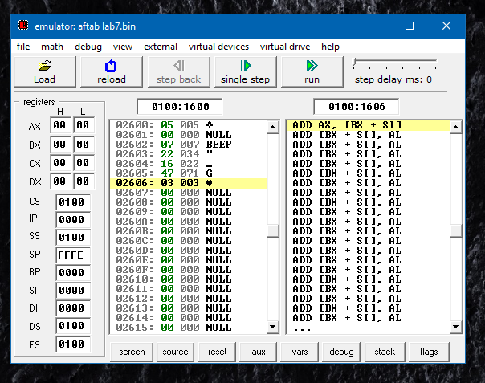

**Flow Chart :**

**No**

**Yes**

**Output :**

| **Input Values** | |
| --- | --- |
| **1600H (Counter)** | **05** |
| **1601H (no change)** | **00** |
| **1602H** | **07** |
| **1603H** | **22** |
| **1604H** | **16** |
| **1605H** | **47** |
| **1606H** | **03** |

| **Output Values (Result)** | |
| --- | --- |
| **1602H** | **47** |
| **1603H** | **22** |
| **1604H** | **16** |
| **1605H** | **07** |
| **1606H** | **03** |

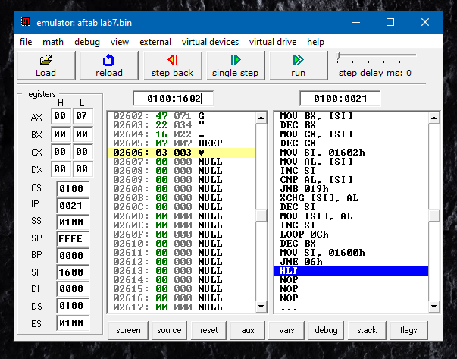

**Result :**

Program to Sort Numbers in Descending Order in 8086 Microprocessor was implemented successfully.